Scala: REPL from eclipse.

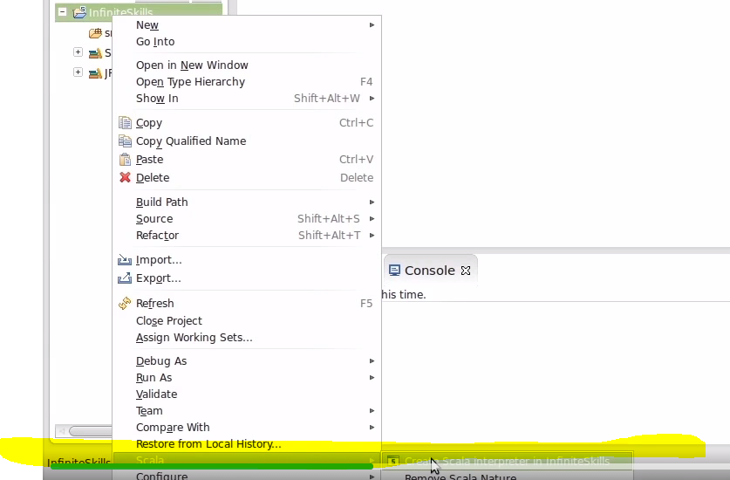

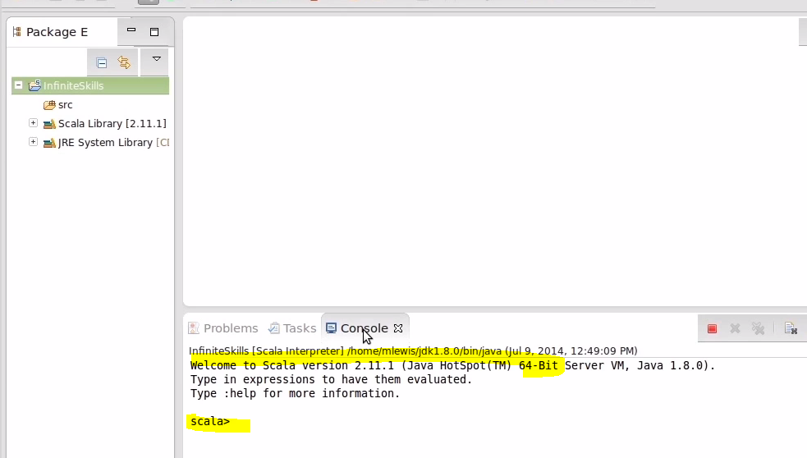

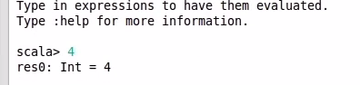\

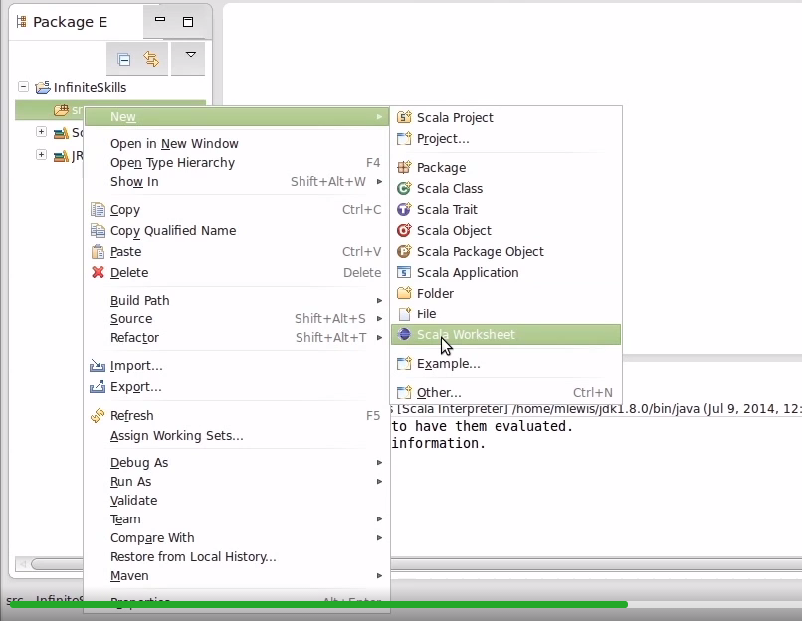

New Scala Worksheet will create Object in scala.

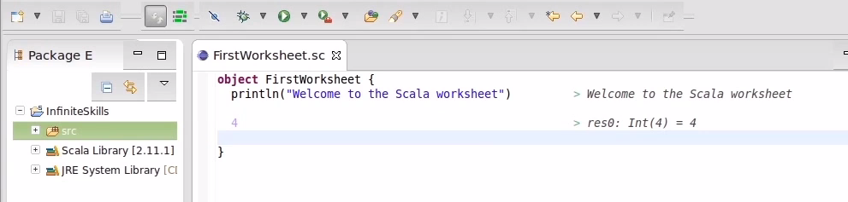

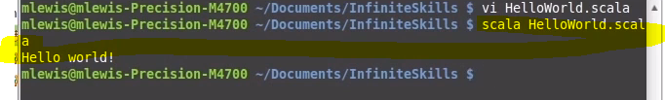

Using textfile to create object and run them by scala

**Lecture 6: Type Hierarchy**

In Java all the objects starts with Capital letter like Integer and String. There are primitives like Int etc. but in case of Scala everything is object

Like Int, Double (These are types in Scala and they are objects as they are started with capital letter).

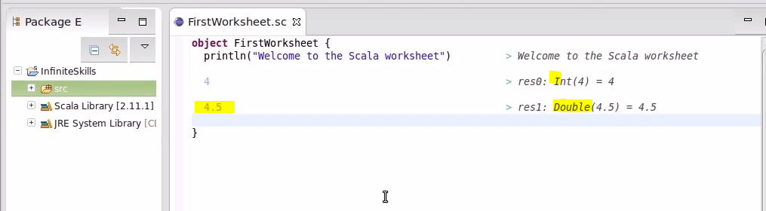

In Scala we can convert from one type to other with toString,toInt etc methods compare to java with using parse.

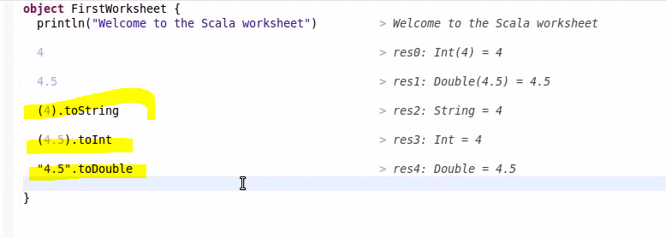

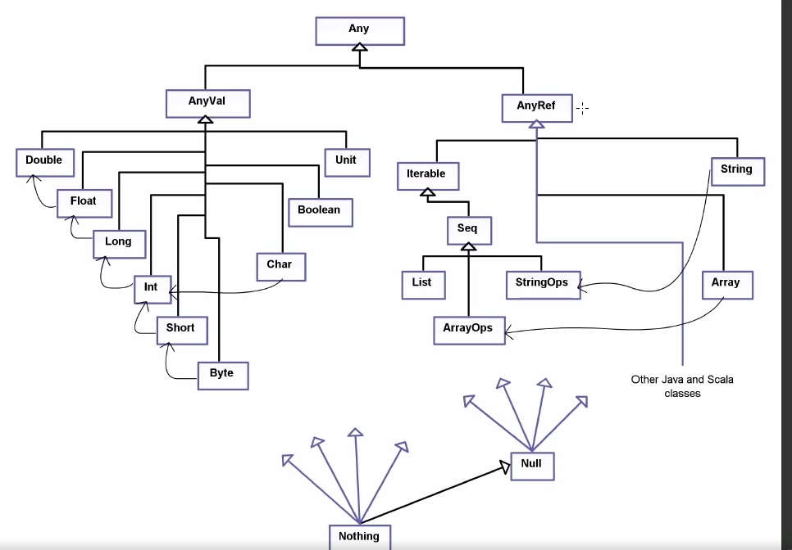

* AnyVal are object types which we create like Int, Double, (Note: Starts with capital letter) like primitives in java
* Anyref are the object types which we get from library similar to arrays, iterable string etc (Note: Starts with capital letter) like object types in java

**NULL:** any objects inside anyref can be made nullable.



Unit: It is similar to Void in java.

Nothing: It is sub type of everything. last class of everything.

**Lecture 7: Variables**

**Two keywords are used in Scala while defining variables. Var and Val**

**Val is immutable and Var is mutable.**

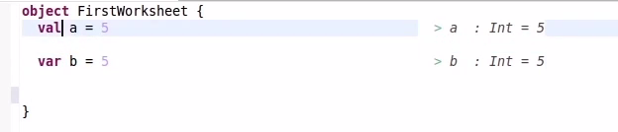

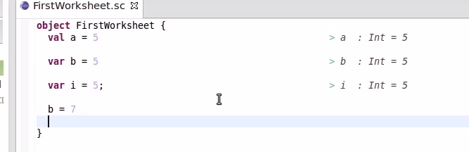

Change the values of var and val and see if you are getting any errors.

**Tuples:** Tuples are used when function is going to return multiple values. Tuples are used when you are returning more values. Take an example of employee class where you return list of employees. In Java we create an employee object and return it with List of Employees. This can be handled well in Scala.

Example, if it’s returning only 2 values, then you have to create class and then hold in java which is painful.

Val (c,d)=(3,5)

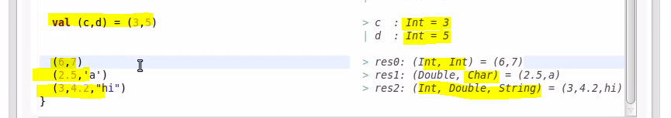



**Lecture 8: If Expression in Scala**





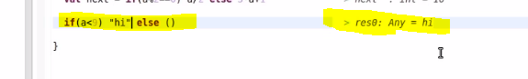

**Scala will fill in expression on it itself and return Any value if there is more than one data type.**

**Lecture 9: Match Expression in Scala**

**Match is more like switch but it is more powerful than switch.**

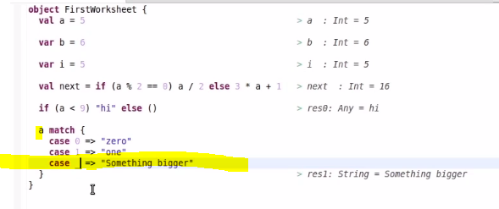

**_ is the operator for anything or something. It can be replaced with any value.**

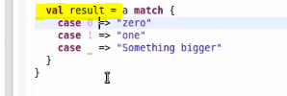

**There is no default and break in scala.**

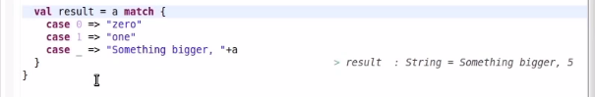

**Patterns can be variable names. Example i below, which bounds to value there i.e. a*3 and a was 5 so it is bound to value of 15.**

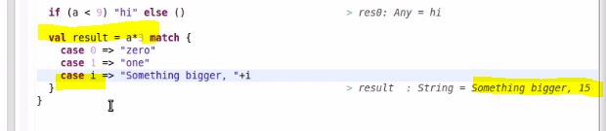

**Defining variable itself, which is value here.**

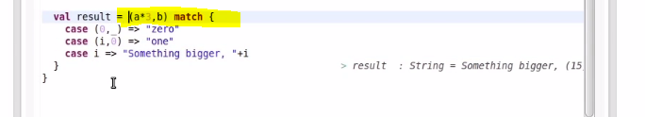

**Tuples here. _ can be anything and i is original value.**

**Case(i,0) will be true for a*3,b value**

**Case i => will be bound to anyvalue i.e default in java**

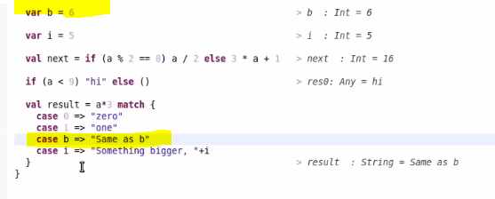

**It always prints same as b. because it is default value as it is not checking value with b. to declare variable value you have to surround them with ‘b’**

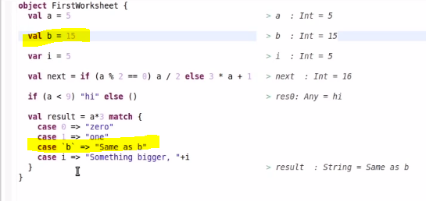

**Declaration of variable b should be val not var if used inside match with variable. See above screenshot, check error by changing to var for b.**

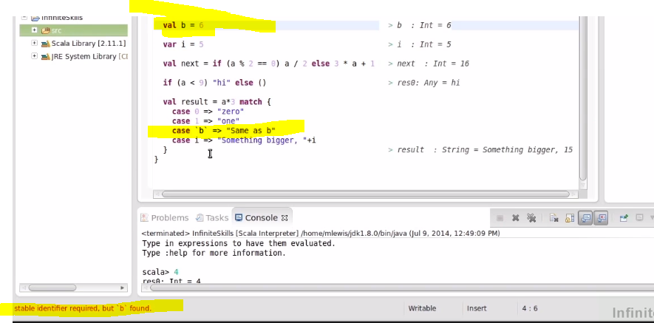

**Lecture 10: Functions and Recurrsions**

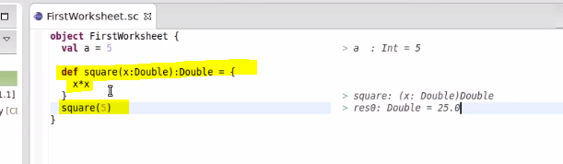

**Functinname(varname:datatype):returndatatype ={ last statement will be return by default.}**

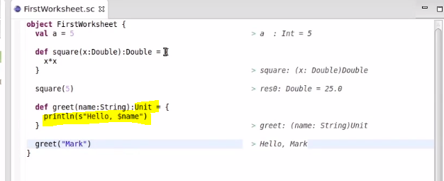

**Return type of print is Unit since you are simply printing the values.**

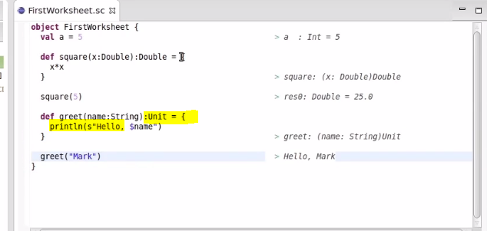

**We can remove = for functions which are returning Unit. Please see below.**

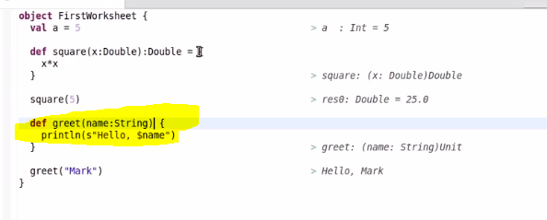

**Always try to use = and return type for functions.**

**Lecture 11: Recursive Functions**

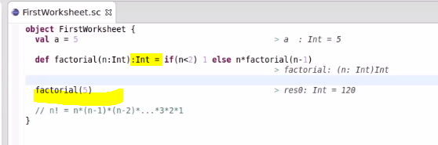

**Recursive functions should have return type. You cannot have function without return type for recursive functions. See below screenshot, you got an error for not specifying return type.**

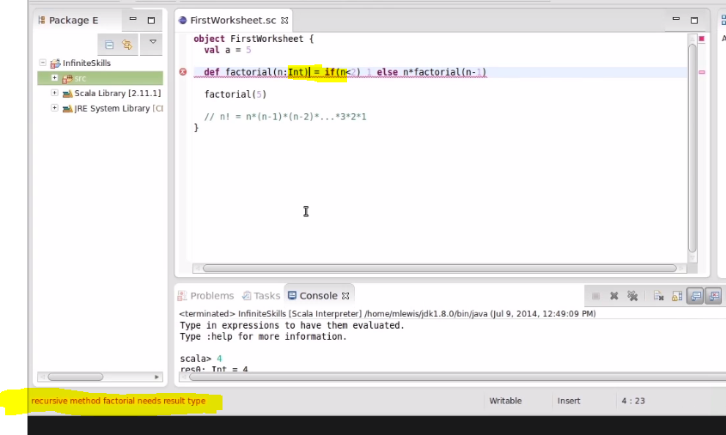

**Recursive functions cannot be called more than 1000 times you will get stack overflow error.**

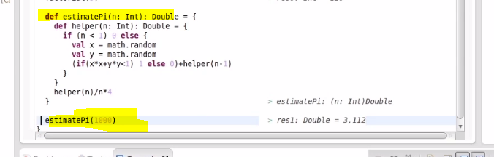

**Lecture 13: Collections**

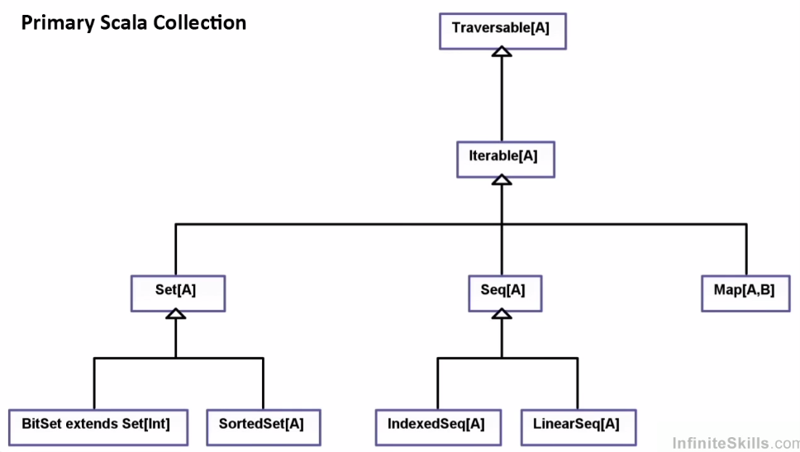

**Two type of collections are present. Mutable and immutable collections.**

* Inerrable you can get iterator.
* Set is collection that doesn’t allow duplicates.
* Seq allows duplicates and keeps the order of the elements in it. Sorted set has ordering based on nature of ordering
* Map is like look up values. Key value pairs.

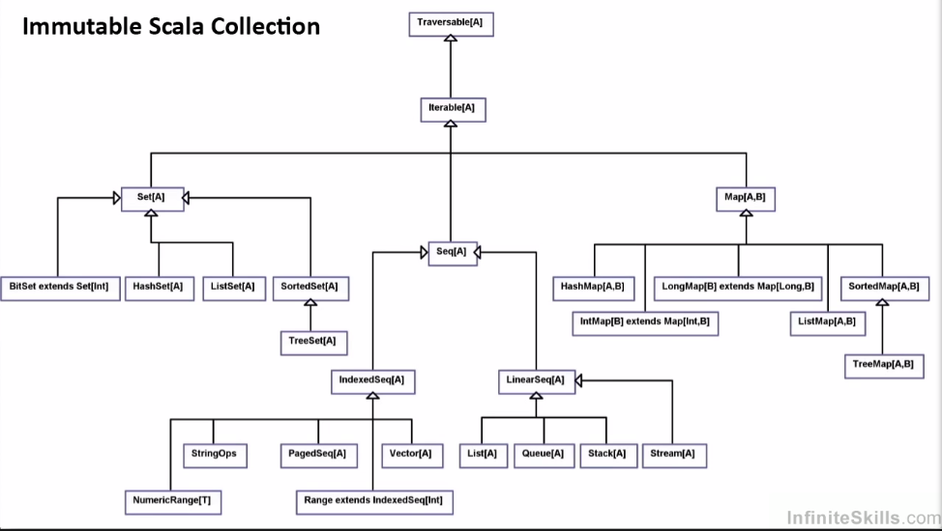

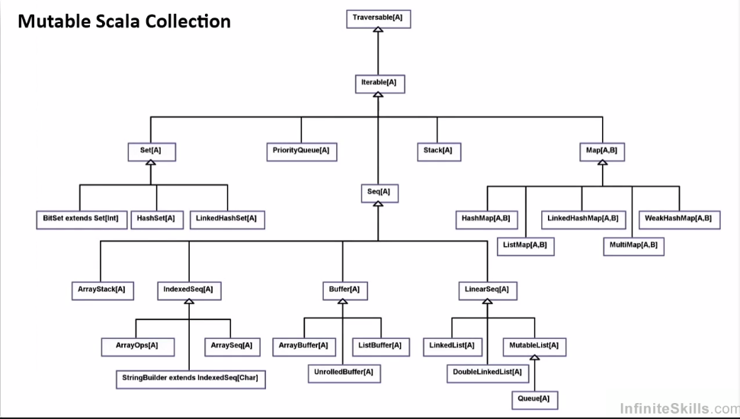

**Lecture 14: Collections**

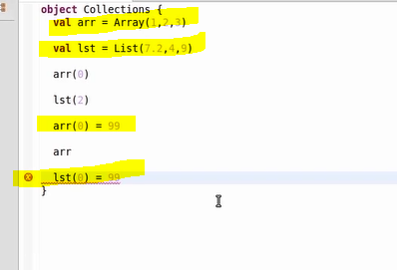

Array is mutable but list is immutable. You can see it in the above screenshot.

**\*\*\*\* arrays or list accessed by () not [] in scala.**

**\*\* List is immutable and is stored as singly linked list which is immutable. Since it is singly linked, you can add elements i.e. making mutable on the head of it by using operator :: so , 14:: list will add 14 to the list . if list has {6,7,8} then the final list will be {14,6,7,8}. :: called as cons.**

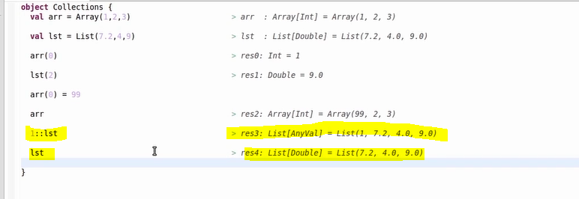

**You can see new element added with 1::lst which is mutable and then original list is not mutable. We created new list from the existing list using :: by adding new one ( This will return new list not the old one i.e. it’s not updated but creates new one which will be again new list which cant be mutable)**

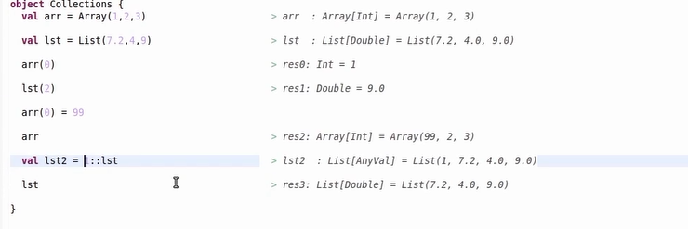

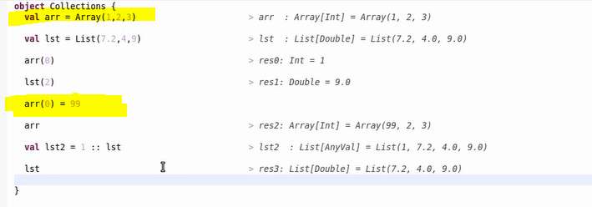

**Array is mutable here.**

**Lecture15: Arrays, List, Vector and Buffer.**

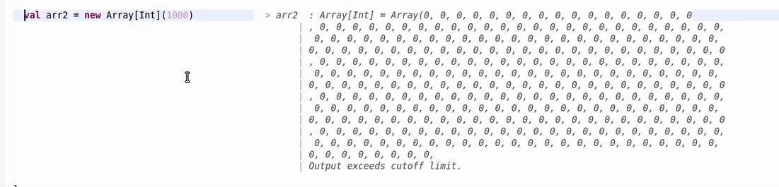

**Array in Scala for big value. But we should not do like this**

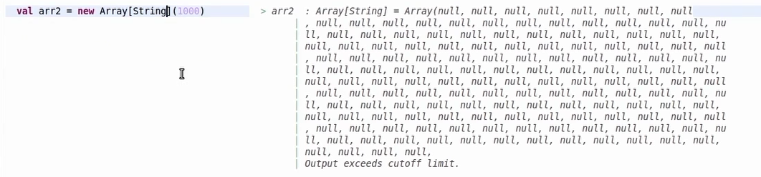

**String array in Scala for big value. But we should not do like this**

**We create larger arrays in scala using fill and tabulate.**

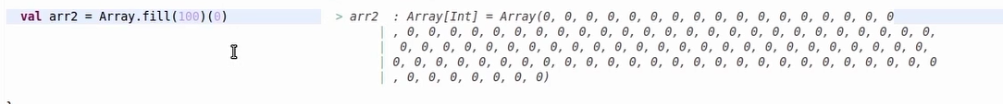

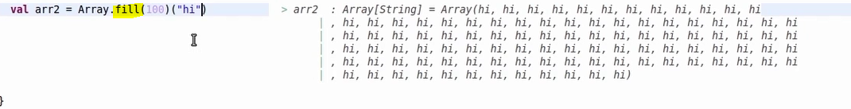

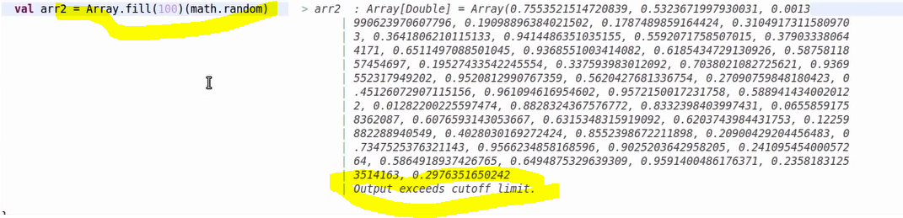



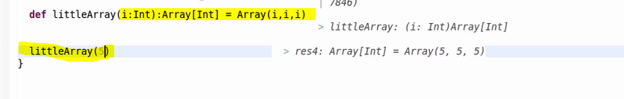

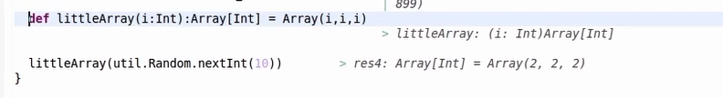

**This will return numbers between 0 and 9.**

**Tabulate: it will take second argument as function and we will pass lambda expression for it.**

**Lambda expression has one argument (which is index in this case and we are passing the square of the index back)**

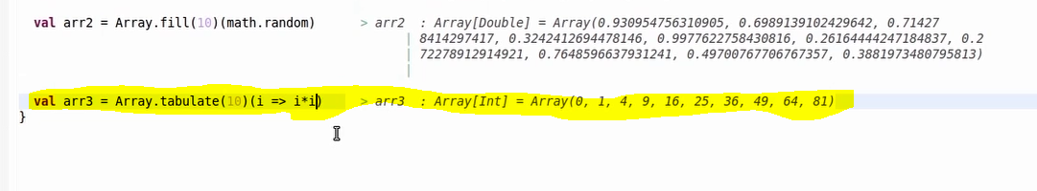

**Lecture 16: Arrays , Buffer, Vector and Ranges.**

**Vector :** Indexable and mutable . also similar to list + array.

List you can index quickly array you can. Array you can mutate and vector you cant.



**Buffer : It** is mutable and it is more like array list in java. ArrayBuffer and ListBuffer. ArrayBuffer Mutable and list is immutable buffer. Buffer means you can grow the size and in case of arrays it cannot grow the size.

You can create buffer as below or using import statemenst too.





By default we get array buffer, to get list buffer mention as below.



ArrayBuffer is preferred choice.

**Ranges:**



Ranges 1 to 10.



Increase the ranges by 2

**** you can also do ranges with floating point numbers but you have to mentioned range by when using floating point numbers.



**Decreasing the range by -1.**



**Lecture 17: Using API**

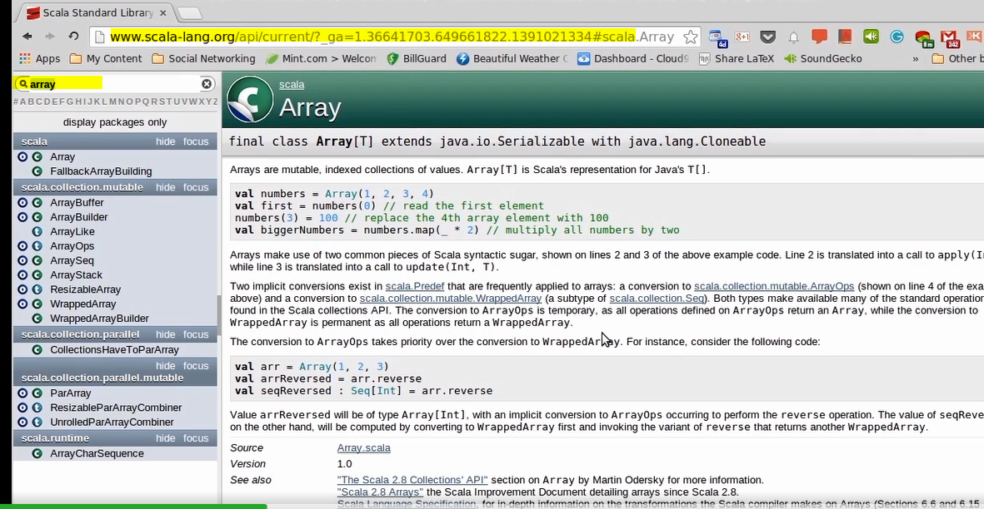

**Implicit conversions -🡪**



**C means companion object and o means object.**

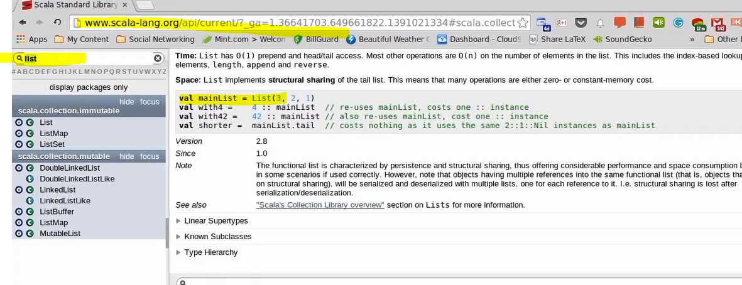

**List objects in scala language.**

**Lecture 17: Regular Methods(will take value as arg)**

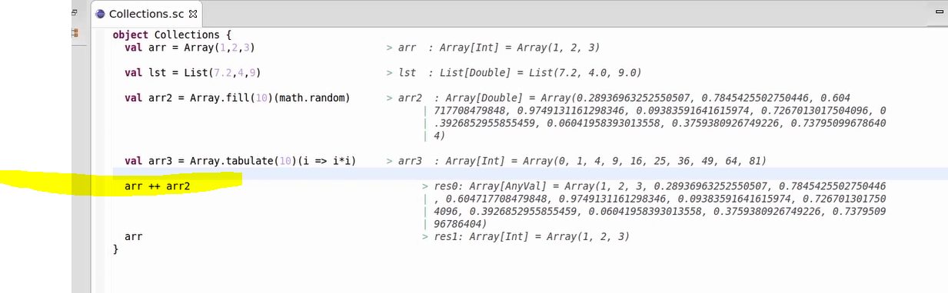

++ operator (arr+arr2)on array concatenates two arrays and result is new array. None of the arrays get modified the ones which were added.



**++:** also gives same output as ++ but there is slight difference. It is right associative instead of left associative.

So it is same aar++:aar2 is equal to aar.++(arr2) and aar2.++:(arr)



**Adding element to array.**



**\*\*\*\*\* +: will add element to the beginning while as :+ will add element to the end. This will create new array but not existing one.**



**Size of array:** you can get size or length method without (). () is optional in Scala

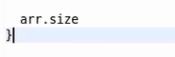

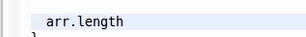

arr.head will give first element and arr.last will give last element.

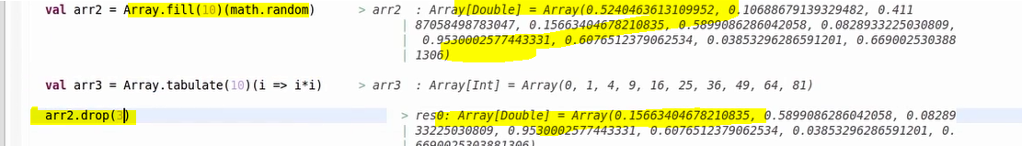

Drop will remove some elements from the list. If 3 then it will remove 3 elements.

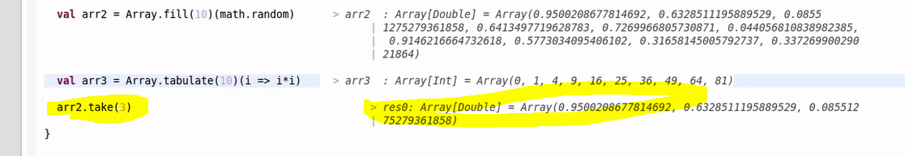

Arr2.take(3) will get first 3 elements from list.

Reverse a list using arr.reverse



*** SplitAt 🡪 Tuple will be return with array.splitAt(4)



Splice 🡪 this will get arrays between the indexes provided in the list.



**Lecture 18: Regular Methods**





***Array starts with Array(1,2)

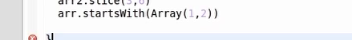

********



Indices: This will range in the array ***********



Maximum value in an array:



Minimum value in an array: arr.min



Sum of all elements in an array



**Converting List to Array to Mutate it:**

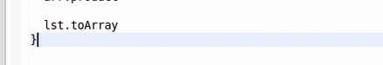

**Convert List to Vector if you don’t want to mutate it:**





**Lecture 20: Regular Methods**

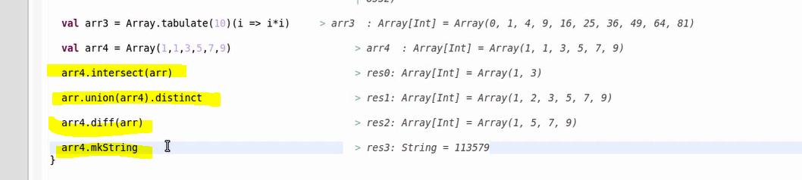

Intersect,union,diff and mkString methods.

If you pass value inside mkString , it will create string with delimiters.

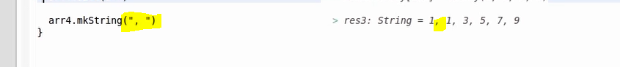



Adding ( and ) to the mkString.



It will create tuple.

**Lecture 21: Higher Order Functions(Filter, Map and Foreach)**

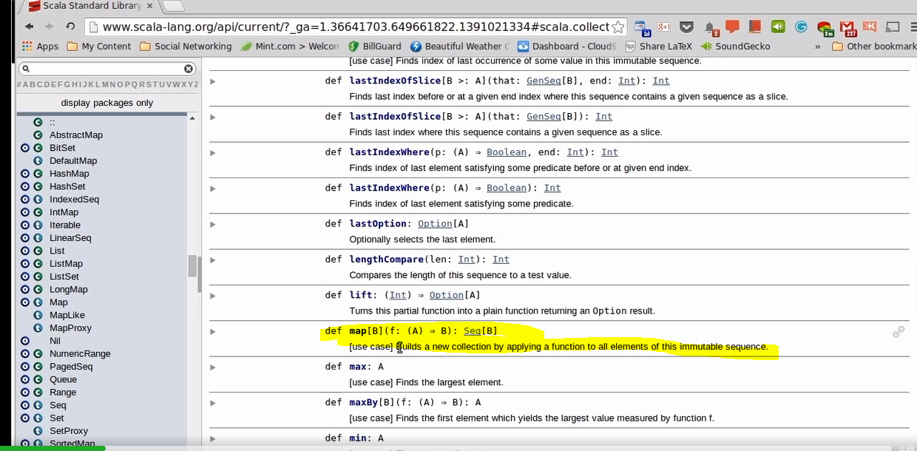

**Map is an example of higher order functions.**

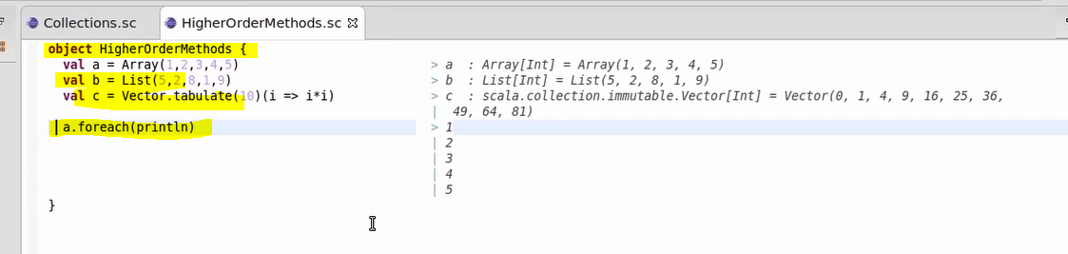

**Foreach: this will take function as argument. In this case println is function which prints value. Foreach is called on each and every element in that array and returns the value after computing.**

**Map taking a function and returning sequence. It is taking function of Type A and returning result of Type B**



**It takes each and every elements and finally return the result of type. It multiple by float value then it will return result of float like res0:Array[Float]**

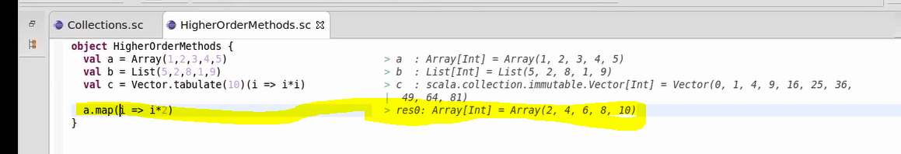

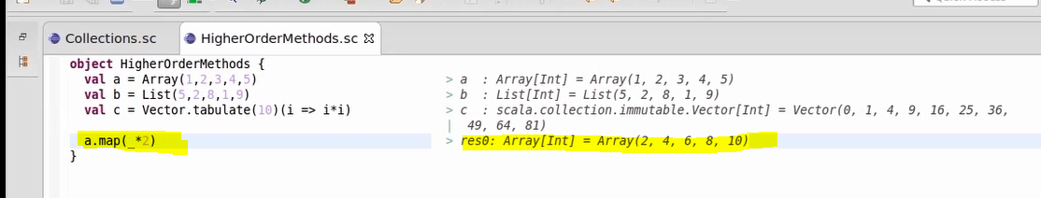

**You can also use _ in map.**

**\*\*\*\*\* _ can be used if every argument in the function occurs once and in the same order then you can use _.**

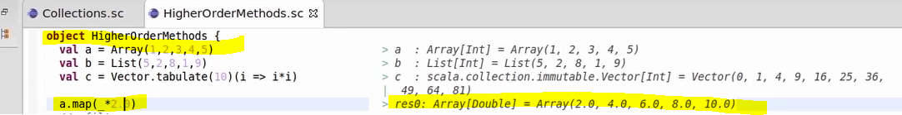



Resulting type got changed to new collection in above example. Collection gets changed every time and new one is created. It’s not updated.



Filter function: It returns list again.

**Flat Map Function:**

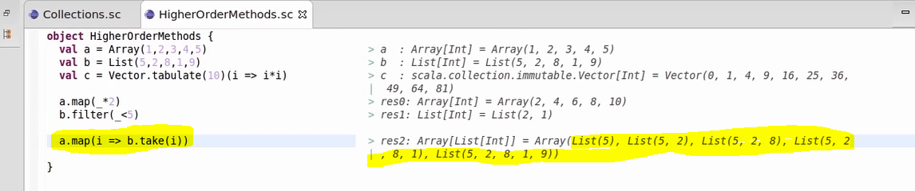

In above code, we are using map function which is taking each value from list and getting the values from b list with take function. This will return Array of Lists in this case which is more like tuple.

**Converting array of lists to array of elements.**

We use flatten method for it. This will return the elements inside the list.

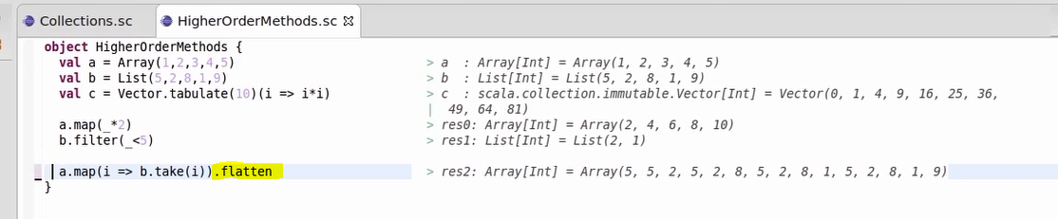





**Reduce method:**

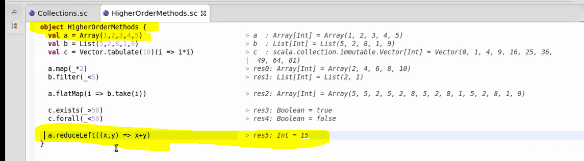

In Array A, we have (1,2,3,4,5) so reduce method will take 2 arguments

Case1: 2 arguments i.e. 1 and 2 and gives result back as 1+2 which is 3.

Case 2: It will take 3 value computed earlier and takes one more argument 3 from list so totally it is 3,3 🡺 3+3

And so on until you gets sum total.

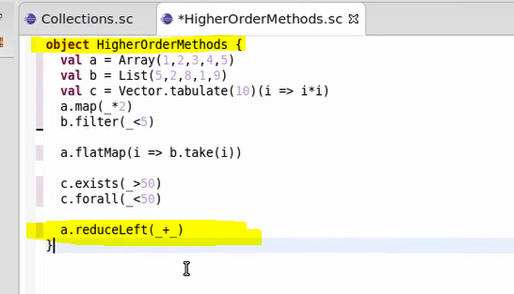

***********We can also use _,_

Reduce should give back the result of same type that collection has . Array[int] so it should give back int after computation

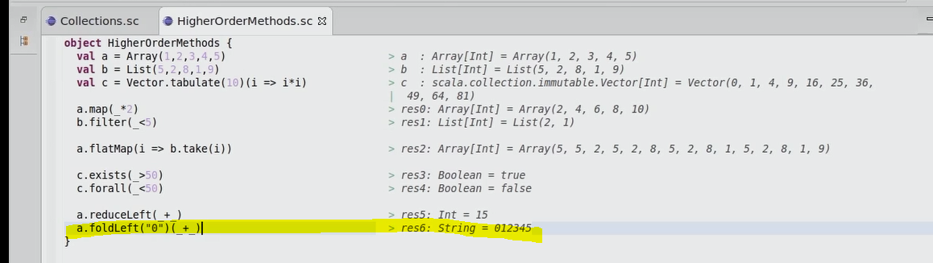

**Maven with Scala:**

**Install** [**http://alchim31.free.fr/m2e-scala/update-site-0.5.1/**](http://alchim31.free.fr/m2e-scala/update-site-0.5.1/) **into eclipse software.**

[**http://scala-ide.org/docs/tutorials/m2eclipse/**](http://scala-ide.org/docs/tutorials/m2eclipse/) **follow this link to install or create scala maven project.**